**Lab: S3 Static Website Hosting**

**Services Used: S3**

1. Launch S3 service from AWS Console
2. Create new bucket for the Static Website Hosting.

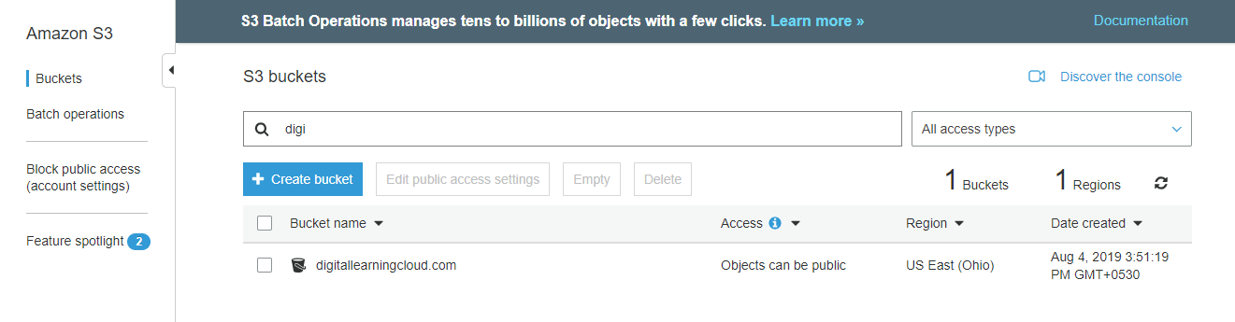

1. Edit public access settings and provide public access.

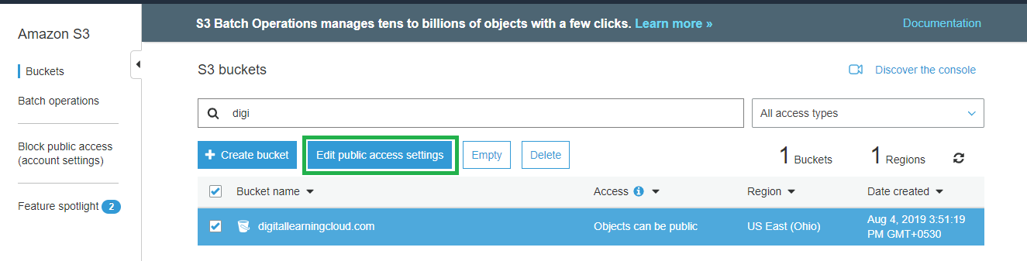

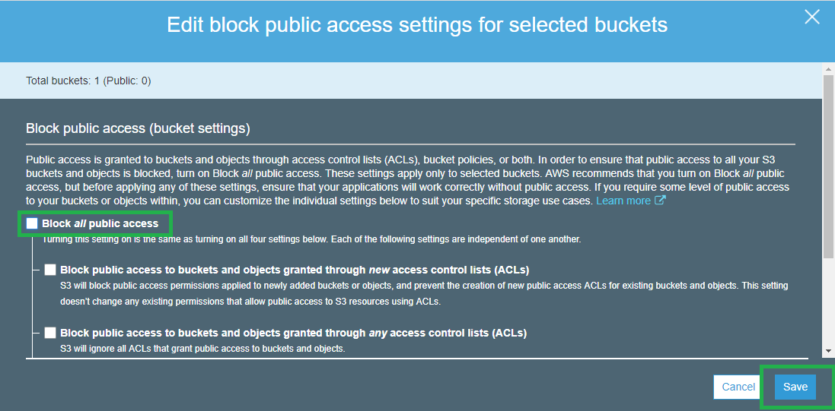

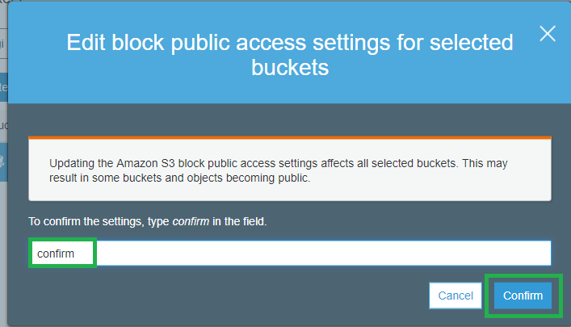

1. Upload the html files, images that will be providing the static website hosting and make them public.

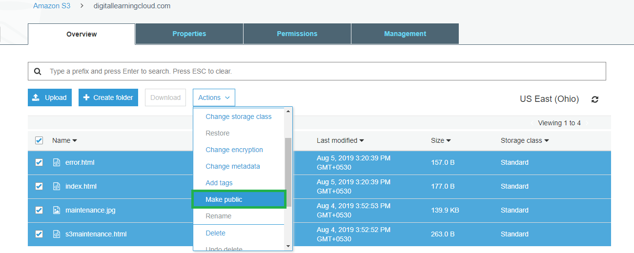

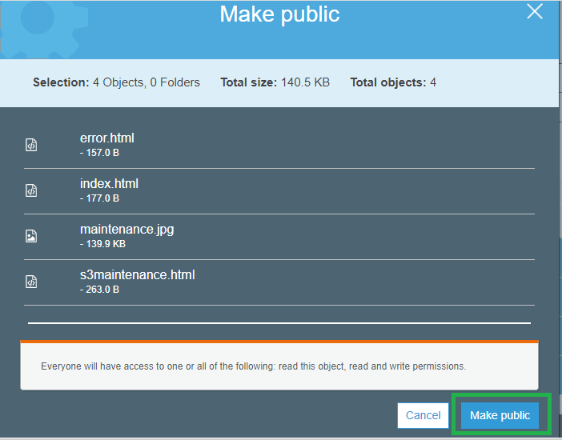

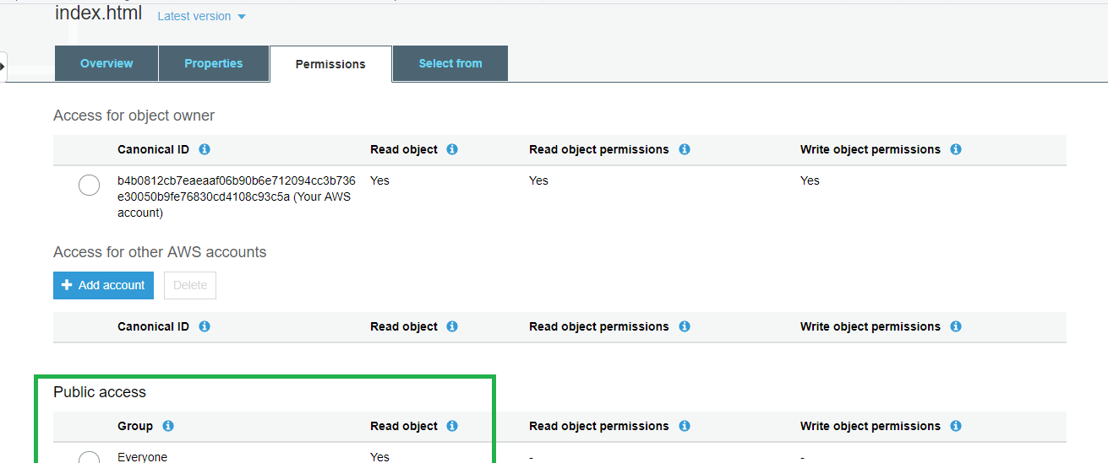

1. Click on the bucket properties.

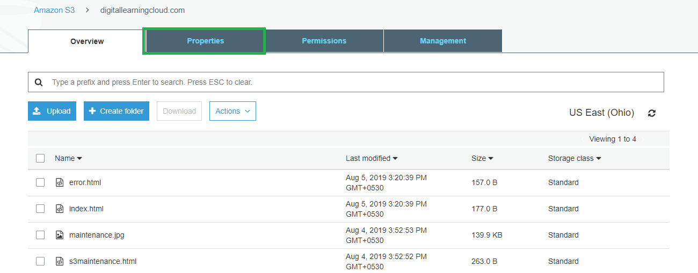

1. By default static website is disabled for the bucket click and enable it.

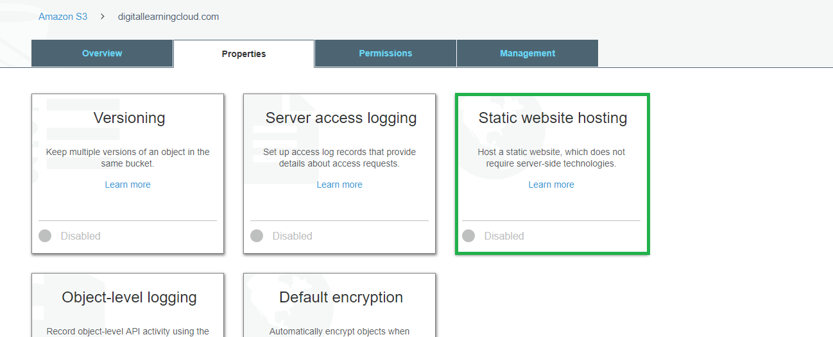

1. Select use this bucket to host a website and provide both index.html and error.html as index and error document. Save the settings.

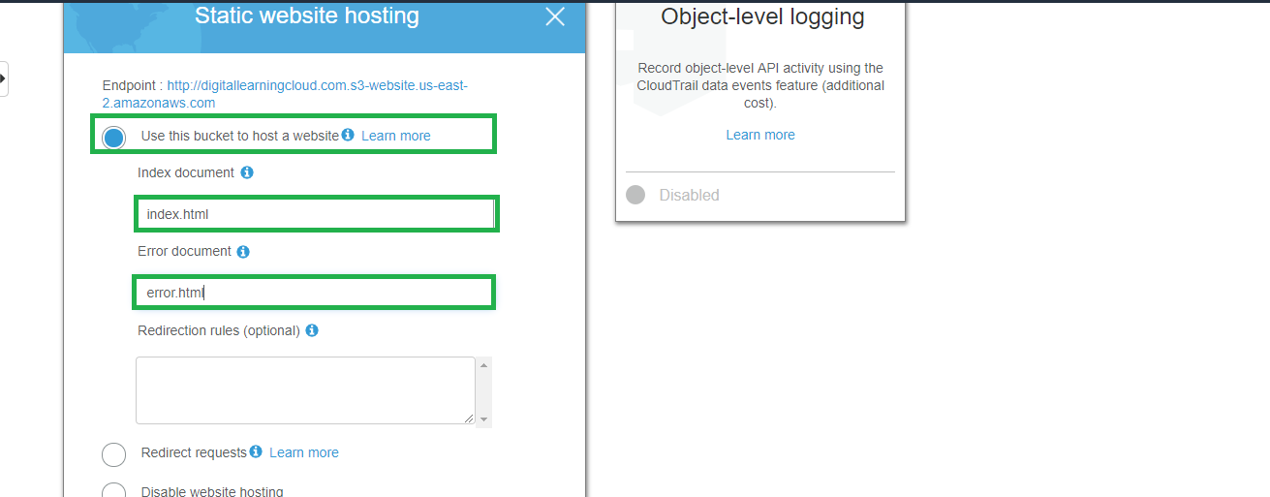

1. Verify the static website is enabled and open the Endpoint in browser.



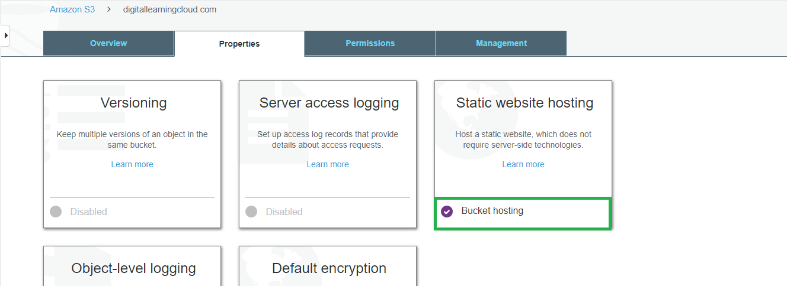

1. Static website is verified and working as expected.

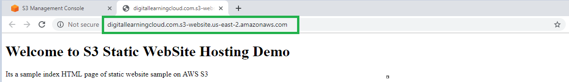

1. Verify error html by adding incorrect characters in the s3 endpoint link and we should be able to see the error from error.html.

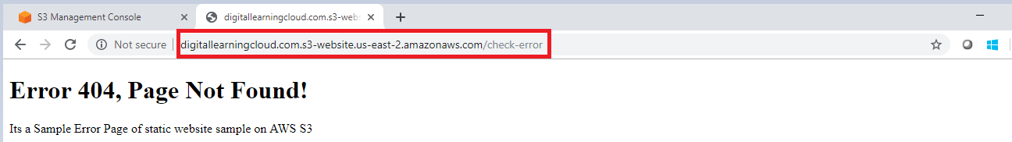

To disable the Static website hosting edit the static website settings and disable website hosting option.

